Moose Jaw Exhibition Company’s
Groundhog Special Schooling Show

ENTRIES CLOSE FRIDAY, FEBRUARY 18, 2022 AT 5:00 PM

Judge: Rod Duncan, Moose Jaw, SK
Course Designer: Robbie Lewis, Moose Jaw, SK
Show Manager: Mel Burns, Moose Jaw, SK
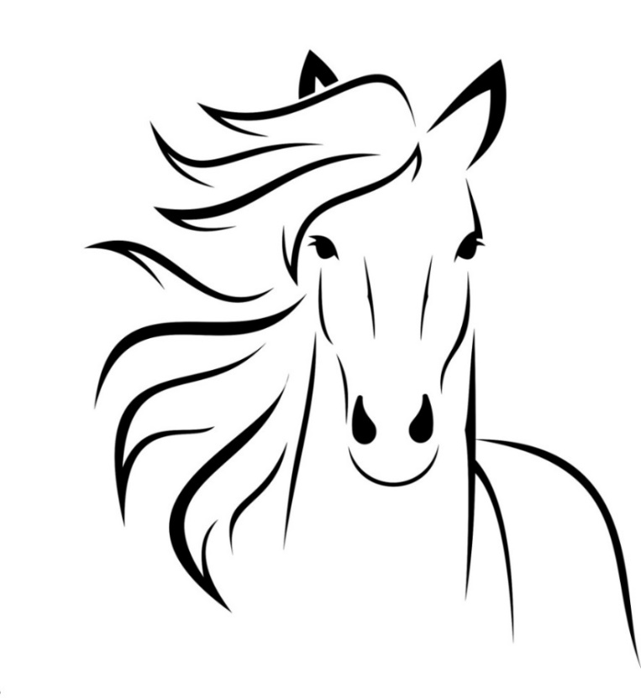
Show Secretary: Marci Perrin, Moose Jaw, SK

** MASKS MUST BE WORN PROPERLY IN ALL INDOOR FACILITIES, INCLUDING WHILE MOUNTED ON YOUR HORSE**

If you are not feeling well, please consider the health & safety of everyone and stay home.

Golden Mile Arena, Moose Jaw Exhibition Grounds
Saturday, February 26 & Sunday, February 27, 2022

**PARTICIPANTS OF THE SHOW MUST HAVE A CURRENT SHF MEMBERSHIP**
Mail Entry Forms & Cheques to:

Moose Jaw Exhibition Company
250 Thatcher Drive East Moose Jaw, SK S6J 1L7
P: (306) 692-2723; F: (306) 692-2762; E: moosejawexh@sasktel.net
E-transfers accepted to: moosejawexh@sasktel.net
GENERAL INFORMATION

OFFICIALS:

JUDGE: Rod Duncan, Moose Jaw, SK

COURSE DESIGNER: Robbie Lewis, Moose Jaw, SK

SHOW MANAGER: Mel Burns, Moose Jaw, SK

SHOW SECRETARY: Marci Perrin, Moose Jaw, SK

VETERINARIANS: Peak Veterinary Health
Phone: (306) 692-4800

OFFICE HOURS: The Show Office will be open at 1:30 pm – 8:00 pm Friday, February 25th. During the competition, the office will open one hour before and close approximately one hour following each show day. Faxed entries will be accepted to the Moose Jaw Exhibition Office at 306-692-2762 provided that they are accompanied by a phoned in payment by Visa or MasterCard. MJ Ex Co Office hours are Monday to Friday 9:00 am to 5:00 pm, and the phone number is 306-692-2723.

STABLING: ALL HORSES MUST SHOW OUT OF A STALL. Stabling is assigned and will be available as of 10:00 am Friday, February 25th until 9:00 pm Sunday, February 27th. Stall fees are set at $30.00 per horse per day – including stall clean out. Shavings may be ordered in advance on the entry forms. There may be additional shavings available for purchase during the event. Tack and feed stalls are available for $15.00 per day and MUST be purchased at time of entry. If you would like to arrive prior to, or stay beyond the times and dates specified, you must contact the Exhibition office in advance to book your stall(s) at an additional $20.00 per horse per night.

UNLOADING: Trucks and trailers will be allowed twenty (20) minutes for unloading at barn doors, and then must be parked in designated areas.

SCHOOLING ROUNDS OVER A MODIFIED HUNTER COURSE WILL BE AVAILABLE FROM 2:00 PM TO 7:45 PM FRIDAY, FEBRUARY 25TH. Fifteen minute time blocks may be purchased for $10 and MUST be paid for prior to riding. SCHOOLING ROUNDS WILL BE LIMITED TO NO MORE THAN 6 HORSES IN THE RING AT ONE TIME. It is strongly recommended to hack your horse(s) in the Duncan so you do not have to spend much time hacking during your schooling round. Schooling rounds will be scheduled on a first come, first serve basis. The arena will be closed following paid rounds.

WARM UPS DURING SHOW: The Jack Duncan memorial building will be available for warm ups during the show.

INHUMANE TREATMENT OF HORSES WILL NOT BE TOLERATED.

The Moose Jaw Exhibition Company will not be held responsible for any damage, injury, loss, or theft to any person, or their animals, or their belongings.

ALL DOGS MUST BE ON LEASHES AND UNDER CONTROL AT ALL TIMES.

GENERAL RULES & REGULATION

ENTRIES must be in the hands of the show secretary by 5:00 pm Friday, February 18th, 2022. Entries will not be processed without payment. Entries received after the deadline may not be recorded in the program. All entries must be made in writing and signed by the owner/agent of the horse and the exhibitor. The parent or legal guardian MUST sign entries of all JUNIOR riders and the junior’s birthdate must be provided. A separate entry form must be filled out for each horse/rider combination, and will be assigned a separate number.

LATE ENTRIES received after the closing date WILL be assessed a $20 late fee, NO EXCEPTIONS. Additional classes may be added to your existing entry form without such late penalties.

MASKS must be worn properly in all indoor facilities, including while mounted on your horse. If you are not feeling well, please consider the health and safety of everyone and stay home.

MEMBERSHIPS: All competitors are required to have a current SHF membership.

REFUNDS/CLASS TRANSFERS: Management reserves the right to refund any entry, minus the office fee. Exhibitors are responsible for errors on their entry forms and will not be refunded because of errors. No refunds or transfers on scratches after 6:00 pm Friday, February 25th, 2022.

CANCELLATIONS: There will be no refund on entry fees after the official closing date of entries, except with a veterinary certificate stating that the horse will be unable to show during the show, or a doctor’s certificate in the case of the participant. If less than 72 hours’ notice is given, with a veterinarian or doctor’s certificate, entry fee refunds may be reduced to 50% of the fees at the discretion of show management. OFFICE FEES ARE NON-REFUNDABLE. If MJ Ex Co cancels the show due to weather or pandemic restrictions, the office fees will be held and all other fees will be refunded

EXHIBITOR NUMBERS will be assigned per horse/rider combination. Provided numbers MUST be worn and visible at all times, including in the schooling rounds, exercise rings, as well as in the show ring. Any exhibitor entering the show ring without the correct exhibitor number may be excused from the class, or may be disqualified in the event of a subsequent protest.

POST ENTERING CLASSES must be done at the show office PRIOR to the start of the class NOT at the gate. Any exhibitor adding in at the gate without following this rule may be disqualified. ONCE A CLASS HAS BEGUN (THE GATE SHUT, OR THE FIRST HORSE JUDGED) NO FURTHER ENTRIES WILL BE ACCEPTED.

MANAGEMENT reserves the right to cancel or combine any class that does not fill to their satisfaction, whereupon exhibitors shall be notified as soon as possible. The show management is not required to hold the gate for anyone not ready on time, this is a courtesy extended at the discretion of the show committee.

ATTIRE: Informal dress attire is okay, however, baggy hoodies/jackets that may get caught up on equipment are not allowed. Braiding is optional. Protective head gear with properly secured and fastened harness which meets ASTM/SEI standards, properly fitted and in good condition, is compulsory for ALL competitors when mounted on a horse on the MJ Ex Grounds.

CROSS ENTRIES: No cross entry from walk trot classes to canter classes per rider/horse combination. Walk trotters may enter ground poles and cross rails.

EXHIBITORS WITH MULTIPLE ENTRIES may ride more than one horse in classes requiring only individual work, regardless of age, up to a maximum of three entries. However, a horse can only be entered once in each class at the show. If there is an elimination round, each horse must be ridden in the actual class by the same rider who rode it in the first round.

IT IS THE ULTIMATE RESPONSIBILTY OF THE COMPETITOR TO ENSURE THAT HE/SHE IS AWARE OF AND COMPLIES WITH THE RULES.

NO STAPLES, NAILS, SCREWS OR TAPE ON THE STALLS – HOOK OVERS AND TIES ONLY.
ADDITIONAL INFORMATION PERTAINING TO THE SHOW

AGE DIVISION: For SHF Heritage Circuit purposes, a competitor will compete in their age division as determined by the Year of Birth as it appears on their Birth Certificate:
~ Junior Riders – 17 years and under
~ Senior Riders – 18 years and over

GATE: Once a class has begun (the gate shut or the first horse judged), no further entries will be accepted.

SATURDAY, FEBRUARY 26TH ~ ENGLISH DAY

OVER FENCE CLASSES: Each horse may enter a maximum of three (3) consecutive heights, and a maximum of four (4) over fence classes per day. This would include hunter classes, jumper classes, equitation over fences, and hors concour rounds.

HELMETS MUST be worn at all times while mounted.

WARM UP: A few minutes will be allowed prior to each height division to warm up over a designated line for horse/rider combos that have not shown in previous over fence classes. The Duncan will also be available.

SUNDAY, FEBRUARY 17TH ~ WESTERN DAY

TRAIL SET UP will take place following the completion of the show on Saturday, February 26th.

OPEN RIDING will be available in the arena following the trail set up on Saturday until 9:00 pm.

JUNIOR HORSE classes are open to any horse five (5) years of age or younger. Two hands on the reins may be used.

TWO (2) HANDS on a shank bit are allowed, but preference may be given to correct position.

GAMES may be ridden in English tack.

ENTRY SUBMISSION CHECK LIST
☐Entry Form
☐Waiver / Request Time for Paid Rounds
☐Copy of SHF Membership
☐Payment for Entry

GROUNDHOG SPECIAL SCHOOLING SHOW

SATURDAY, FEBRUARY 26TH – Start Time at 9:00 am
Judge: Rod Duncan, Moose Jaw, SK
Course Designer: Robbie Lewis, Moose Jaw, SK

101. Ground Poles – Open Card (No Placings) $ 5

102. Cross Rails – Course A $ 10

103. Cross Rails – Course B $ 10

104. 2’0” Open Hunter $ 10

105. 2’0” Open Hunt Seat Equitation $ 10

106. 2’3” Open Hunter (0.70 M) $ 10

107. 2’3” Open Hunt Seat Equitation $ 10

108. 2’6” Open Hunter (0.75 M) $ 10

109. 2’6” Open Hunt Seat Equitation $ 10

110. 2’9” Open Hunter (0.85 M) $ 10

111. Senior English Pleasure $ 10

112. Junior English Pleasure $ 10

113. Walk Trot English Pleasure $ 10

114. Senior English Equitation $ 10

115. Junior English Equitation $ 10

116. Walk Trot English Equitation $ 10

117. Road Hack $ 10

**Indoor Warm Ups will be provided as time permits**

118. 0.70 M Open Jumper (2’3”) $ 10

119. 0.75 M Open Jumper (2’6”) $ 10

120. 0.85 M Open Jumper (2’9”) $ 10

121. 0.90 M Open Jumper (3’0”) $ 10

GROUNDHOG SPECIAL SCHOOLING SHOW

SUNDAY, FEBRUARY 27TH – Start Time at 8:00 am
Judge: Rod Duncan, Moose Jaw, SK

201. Senior Trail $ 10

202. Junior Trail $ 10

203. Senior Showmanship $ 10

204. Junior Showmanship $ 10

205. Walk Trot Showmanship $ 10

206. Senior Western Pleasure $ 10

207. Junior Western Pleasure $ 10

208. Walk Trot Western Pleasure $ 10

209. Junior Horse Western Pleasure (Open to any horse 5 years of age or younger – 2 hands allowed) $ 10

210. Lead Line (No entry or office fee – stall charge is required) N / C

211. Senior Western Horsemanship $ 10

212. Junior Western Horsemanship $ 10

213. Walk Trot Western Horsemanship $ 10

214. Novice Horse or Rider Reining (2 hands allowed – no lead changes) $ 10

215. Open Reining $ 10

216. Senior Barrels $ 10

217. Junior Barrels $ 10

218. Walk Trot Barrels $ 10

219. Senior Pole Bending $ 10

220. Junior Pole Bending $ 10

221. Walk Trot Pole Bending $ 10

2022 GROUNDHOG SPECIAL SCHOOLING SHOW
February 26 & 27, 2022
Golden Mile Arena, Moose Jaw Exhibition Grounds ~ Premise ID: SK4HD7H4P
One Entry per Horse/Rider Combination
$20.00 Late Fees assessed after 5:00 PM FRIDAY, FEBRUARY 18th, 2022
(Entries will not be processed without payment)
_________________

_________________

_________________
Entry #

Name of Rider: ________________________________________________________ Youth DOB: _ MM _ /_ DD_ /_ YYYY__
Address of Rider: _____________________________________________________________________________________________
Phone (H): ___________________ Phone (C): ___________________ E-Mail: ___________________________________________
SHF #: ___________________ *Proof of memberships required
Registered or Show Name of Horse: _____________________________________________________________________________
Age of Horse: __________ Stable With: _____________________________________________
Owner of Horse: __________________________________________________ Owner’s SHF #: ________________________

*IF MJ EX CO CANCELS THE SHOW DUE TO WEATHER OR PANDEMIC RESTRICTIONS,
THE OFFICE FEE WILL BE HELD AND ALL OTHER FEES WILL BE REFUNDED*

Class Number | Class Description | Fees
Office Fee | **Mandatory | $ 15.00
EMT Fee | **Mandatory – Per Rider Fee | $ 5.00
Paid Rounds | $15 for 15 minutes **For paid rounds that will take place on Friday, February 25th only** | $
Stall Fee | $30 per day. ALL horses are required to work out of a stall – includes stall clean out | $
Tack/Feed Stall | $15 per day | $
Tenant Show Fee | $10 – Required for MJ Ex Co tenants only | $
Shavings | $8 per bag. | $
Late Fee | $20 Applies to entries received after 5:00 pm Friday, February 18, 2022 | $
 | DEPOSIT FEE FOR NUMBER | $ 5.00
 | TOTAL FEES | $

Mail Entry Forms & Cheques to:
Moose Jaw Exhibition Company Limited
250 Thatcher Drive East Moose Jaw, SK S6J 1L7
P: 306.692.2723; F: 306.692.2762; E: moosejawexh@sasktel.net

- Make Cheques Payable to: Moose Jaw Exhibition Company
- E-Transfers can be sent to moosejawexh@sasktel.net
- Credit Card Payment accepted by phoning the MJ Ex Co Office at 306.692.2723
GROUNDHOG SPECIAL SCHOOLING SHOW PAID ROUNDS TIME REQUEST FORM
Friday, February 25th, 2022
Rules/Regulations:
- Fifteen minute time blocks may be purchased for $10. Payment must be attached with the warm up request form.
- All horse/riders must be registered with the competition to be eligible for a warm-up time.
- Schooling rounds will be limited to no more than 6 horses in a ring at one time.
- MJ Ex Co will not be responsible for grouping people together to share the ring.
- Each horse/rider combination is only allowed to book 1 fifteen minute time slot. A rider can book more than 1 fifteen minute time slot if riding a different horse in each time slot.
- All warm-up requests will be scheduled on a first come, first serve basis.
- All riders must be a member of the SHF.
- Riders will be notified of warm up schedule the Wednesday before competition via email.
- Professional etiquette must be maintained by all competitors and coaches.
- No riders will be allowed to ride in the ring during the warm-up time without purchasing a block of time.
- Other warm up arenas will be available for use.
RIDER NAME: _____________________________________________________________________ SHF#______________________

PHONE#_____________________________ E-MAIL: _________________________________________________________________

For more riders please list on separate piece of paper.

Please indicate your 1st, 2nd, and 3rd choice of time slots. Please indicate your
earliest time possible as one choice to help us meet everyone’s needs.
☐ 2:00 | ☐ 3:45 | ☐ 5:30 | ☐ 7:15
☐ 2:15 | ☐ 4:00 | ☐ 5:45 | ☐ 7:30
☐ 2:30 | ☐ 4:15 | ☐ 6:00 | ☐ 7:45
☐ 2:45 | ☐ 4:30 | ☐ 6:15
☐ 3:00 | ☐ 4:45 | ☐ 6:30
☐ 3:15 | ☐ 5:00 | ☐ 6:45
☐ 3:30 | ☐ 5:15 | ☐ 7:00

Release and Waiver of Liability

I ____________________________________, in consideration of being permitted to participate in the 2022 GROUNDHOG SPECIAL SCHOOLING SHOW or in consideration of a horse owned by me being allowed to participate in the above named show (herein after referred to as The Show) and being aware of the dangers inherent in equestrian competition, do for myself, my heirs executors, administrators and assigns hereby release and forever discharge, the Show, the Show committee, its officers and staff and the Saskatchewan Horse Federation and Equine Canada and their officers, directors, agents, employees and associated of and from any and every claim, demand or action, or right of action of whatever kind of nature, either in law or in equity arising from or by reason of any bodily harm or injury or personal injuries known or unknown, death or accident which may occur as a result of my horse’s participation in the Show, or any activities connected with the Show, whether by negligence or not. It is further agreed that I will indemnify the Moose Jaw Exhibition Company, Show committee, Saskatchewan Horse Federation, and Equine Canada from any and all loss, liability and damage or costs they may incur due to the participation of myself or my horse in the Show whether caused by my negligence or otherwise.

Signature of Rider or Guardian if under 18 years of age: Printed Name:

_____________________________________________________ _____________________________________________________

Signature of Participant: Printed Name:

_____________________________________________________ _____________________________________________________

Signature of Owner/Agent of Horse: Printed Name:

_____________________________________________________ _____________________________________________________

